ME579 - Final Project Proposal:

Euler-Lagrange Drone Dynamics and Trajectory Control

Chunhua Ying

**Objective**

Understand the basics of quadcopter modeling and control, complete a self-coding program to achieve the drone dynamic and trajectory control. Finally, design a robust drone delivering task.

**Content**

1. Mathematical model of Euler-Lagrange drone dynamics in MATLAB.
2. Validation using the example case.

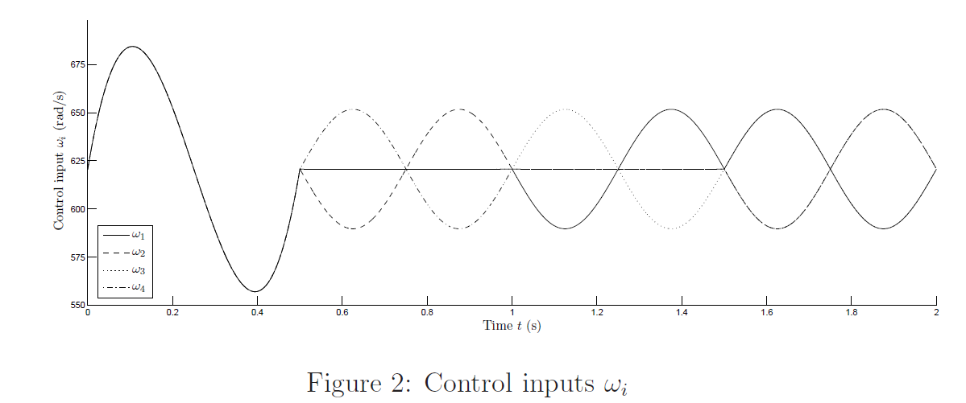

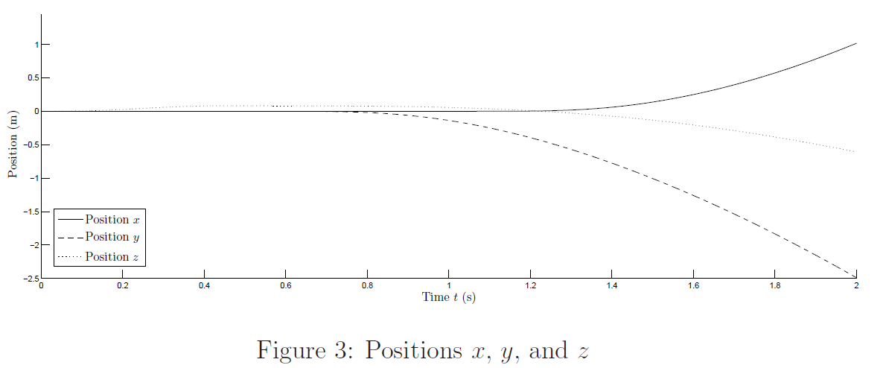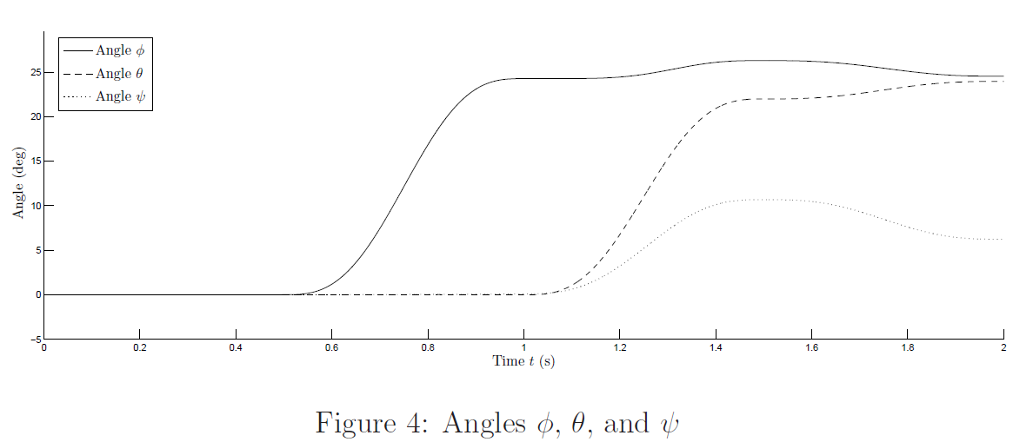

1. Trajectory control

Test:

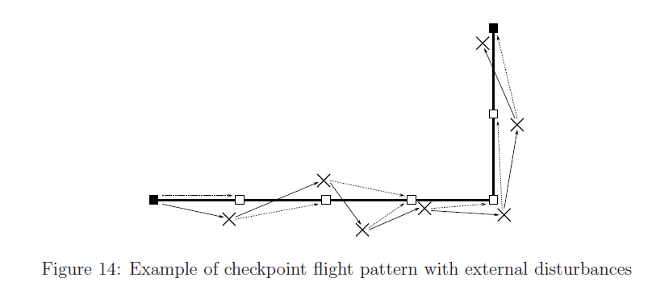

Design:

* + 1. Pre-defined h0, hd, W0,whileP0 as the delivering office station or vehicle position.
    2. Input destination coordinates(customer apartment) P1 and box weight Wbox, achieving an safe drone delivering mission.

